Provincial Grand Lodge of Londonderry & Donegal
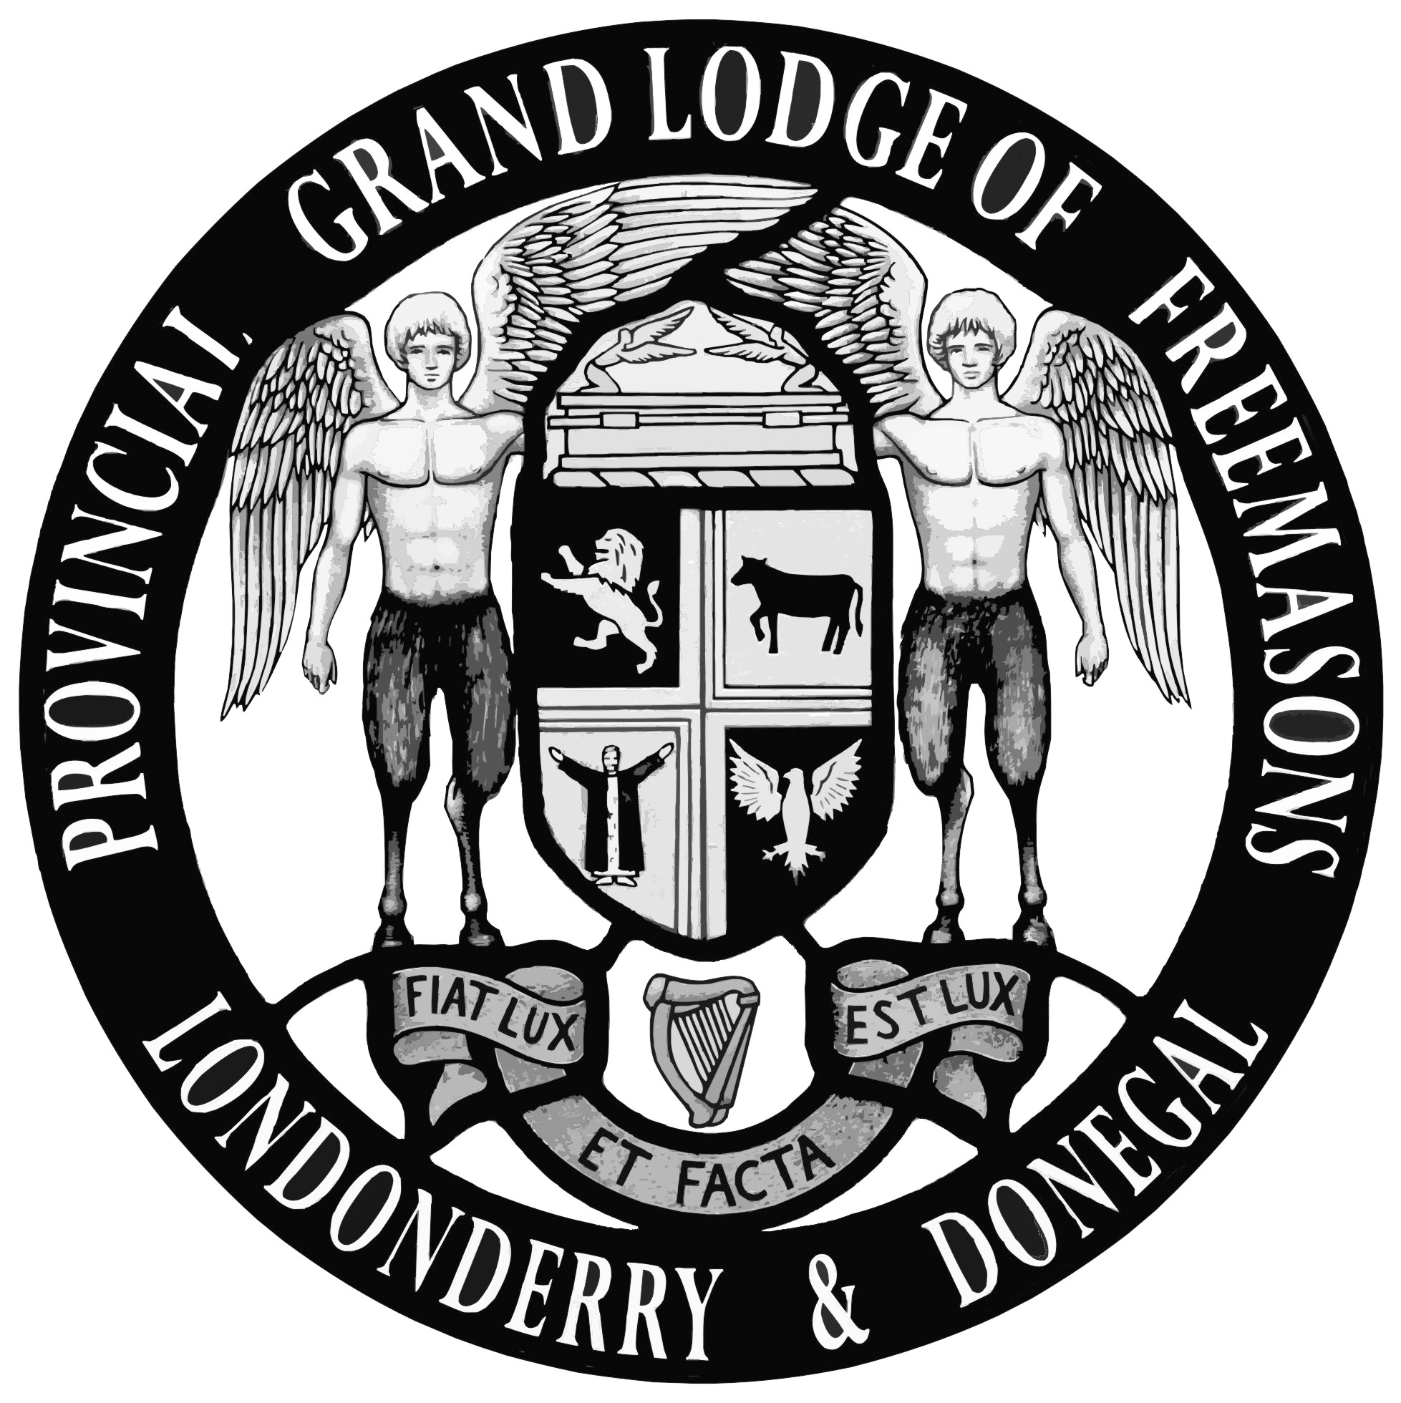

GDPR PERSONAL DATA SHEET

Please fill in the following information online, print it out, SIGN and send or give to your Lodge Secretary
- Lodge Name: Click here to enter Lodge name.
- Lodge Number: Click here to enter number.
- Christian Name(s): Click here to enter your name.
- Surname: Click here to enter your name.
- Date of Birth: Click here to enter D.O.B (DD/MM/YY)
- Address: Click here to enter your address
- Post Code: Click here to enter your Post Code.
- Mobile: Click here to enter your mobile number.
- Home: Click here to enter your home phone number.
- Work: Click here to enter your work phone number.
- Email: Click here to enter your email
- Occupation: Click here to enter your address

I hereby confirm that I have provided the personal information detailed above freely to the Lodge named and I HEREBY CONSENT to my personal data being used in accordance with the Data Protection Notice attached hereto and which I have had the opportunity to review prior to giving my consent.

Signed:_____________________________________________________________________
Dated:___________________________

